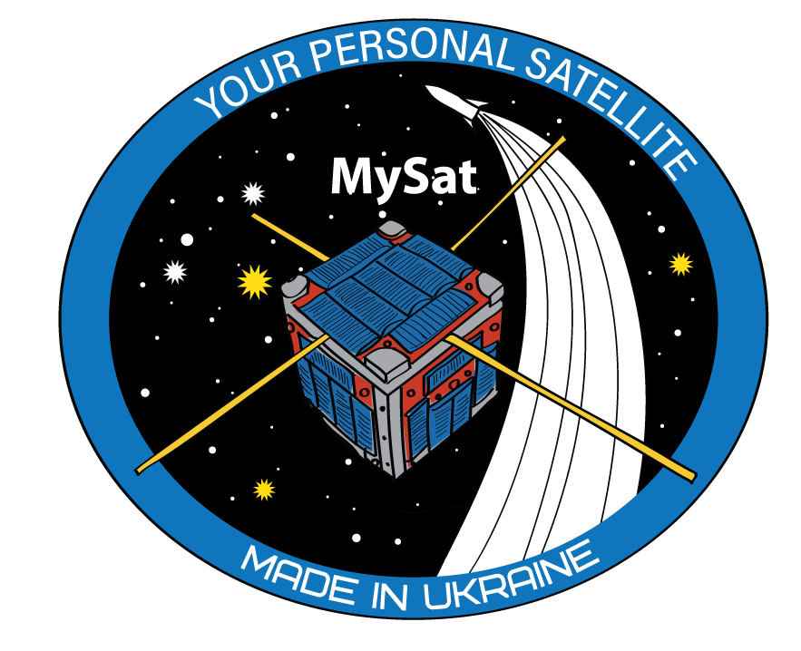

**Howdy! owner of the MySat Satellite Kit!**

**Congratulations, you are one step closer to becoming a space engineer and flight control operator.**

You keep in your hands the first beta version of the MySat Satellite Kit. We created MySat to show how real satellites work in Earth orbit. In skilled hands, our satellite kit will help you to learn the basics of programming, physics, electronics and orbital mechanics.

Your MySat Kit is a 2-in-1 - educational kit and model of a real satellite. You can assemble your MySat satellite right at home and control it in the same way as real satellites - by sending commands for every feature, just by using programming language.

MySat features offer many opportunities to experiment for space fans, young scientists, children and students. We want to give you a tool for research, exploration, knowledge sharing and play. The satellite kit will teach children to love science, stimulate the emergence of future space engineers, and thus drive scientific progress in space exploration. This will allow the US to take its position in the NewSpace age.

Now MySat is being tested and we will be grateful for your feedback about your use and functioning of the satellite features. If you have noticed bugs, problems with the satellite or have suggestions that will help us improve it, write to us at hello@mysatkit.com.

**Who will be interested in the MySat Kit?**

The satellite kit is interesting for everyone passionate about space exploration: adults and children. It is a cool hobby, useful tool to learn IT skills, and a happy family time together.

**Where to find instructions and firmware?**

You can find the firmware, libraries for launching the satellite and instructions on the MySat repository on GitHub: <https://github.com/MySatKit>. If you have any questions, let us know at [hello@mysatkit.com](mailto:hello@mysatkit.com)**.**

**The MySat satellite does not require soldering, and the process of assembling is very simple.**

**Does the MySat model function like real satellites?**

The MySat Kit has all the functionality of a real nanosatellite: receiving and processing commands for the camera, collecting telemetry about the state of the device and the environment (lighting of each side, temperature, battery parameters, position in space, position relative to the Earth's magnetic field, etc.), power control module.

More than that, MySat looks like a real CubeSat satellite that NASA and SpaceX are launching on their rockets. Google next “*NASA cubesat mission SpaceX*” and read more about CubeSat technology.

**What can MySat satellite do?**

Your personal satellite consists of a number of sensors and components that will teach you basics of working with real satellites.

* There is a camera that can take pictures on your command - you will program the camera yourself, just like for real satellites.
* You can also light your own star by programming it with a special command - there is a special powerful LED on board the satellite, which emits light and has a spectrum similar to the spectrum of our Sun.
* Light sensors (photodiodes) - will show you how the satellite is located relative to the Sun and Earth.
* To orientate in space you will be using sensors - an accelerometer and a gyroscope.
* For more accurate positioning, your personal satellite is equipped with an electronic compass.
* Temperature, pressure and humidity sensors are placed in the satellite so that you can study the environment. The pressure sensor - a barometer, will also help you measure height.
* The satellite has its own accurate clock. You will need it to program your satellite and to perform tasks at a specific time. Usually satellites do not execute commands immediately, they must be programmed to execute when they fly over a given point on Earth at a given time.
* The satellite is equipped with its own power system and battery. By monitoring their parameters you will know how much energy is left and when the satellite needs to be recharged. The satellite, like the real CubeSat, will be turned on using the RBF mechanism (Remove Before Flight).

But that's not all, in the future your personal satellite can be modified with additional modules and sensors.

We have prepared versions of the MySat Satellite Kit with a special design, with a metal frame, a special case that can carry your MySat and other electronics.

**Need help?**

Ask a question by messaging our team on Facebook Messenger <https://m.me/Mysatkit>